**THE SPARK FOUNDATION**

**REPORT ON**

**CLOUD COMPUTING**



**Submitted by:**

**jyoti Sharma**

**CONTENTS**

1. Introduction to cloud computing
2. What is cloud computing?
3. Cloud computing services
4. Cloud computing platforms
5. AWS
6. Microsoft azure
7. Google cloud platform
8. Which platform is better?
9. Conclusion

**Introduction to cloud computing**

Cloud computing is the delivery of computing services such as server , databases , storage , networking , software , analytics , intelligence, and more over the cloud.

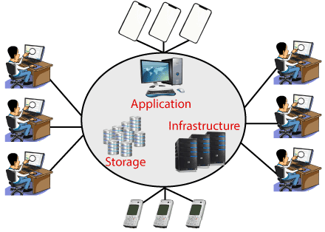

Cloud computing provides an alternatives to the on-premises datacentre, we have to manage everything , such as purchasing and installing hardware , virtualization , installing the operating system , and any other required applications , setting up the network , configuring the firewall , and setting up storage for data . After doing all the set-up , we become responsible for maintaining it through its entire lifecycle.

But if we choose cloud computing , a cloud vendor is responsible for the hardware purchase and maintenance . They also provide a wide variety of software and platform as a service. We can take any required services on rent .

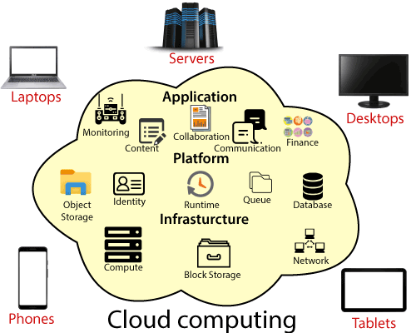

The cloud environment provides an easily accessible online portal that makes handy for the user to manage the compute , storage , network , and application resources . some cloud service providers are as in following figure.

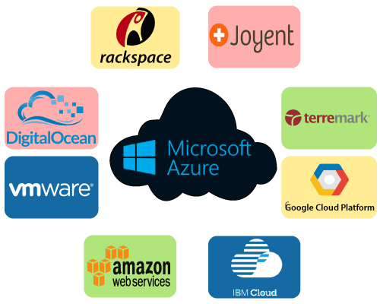

**What is Cloud Computing?**

Cloud computing is the delivery of computing services like servers, storages and more over the Internet. The companies that offer these computing services are called cloud providers. They charge for **cloud computing services** based on usage.

Cloud computing is usually classified on the basis of location, or on the service that the cloud is offering.

Based on a cloud location, we can classify cloud as:

* Public
* Private
* Hybrid
* Community Cloud

Based on a service ,we classify as:

* **IaaS**(Infrastructure-as-a-Service)
* **PaaS**(Platform-as-a-Service)
* **SaaS**(Software-as-a-Service)

### ****Cloud Types:****Private, Public and Hybrid, Community

* **Public Cloud** – Whole computing infrastructure is located on the premises of a cloud computing company that offers the **cloud service**.
* **Private Cloud** – Hosting all your computing infrastructure yourself and is not shared. The security and control level is highest while using a private network.
* **Hybrid Cloud** – using both private and public clouds, depending on their purpose. You host your most important applications on your own servers to keep them more secure and secondary applications elsewhere.
* **Community Cloud** – A community cloud is shared between organizations with a common goal or that fit into a specific community (professional community, geographic community, etc.).

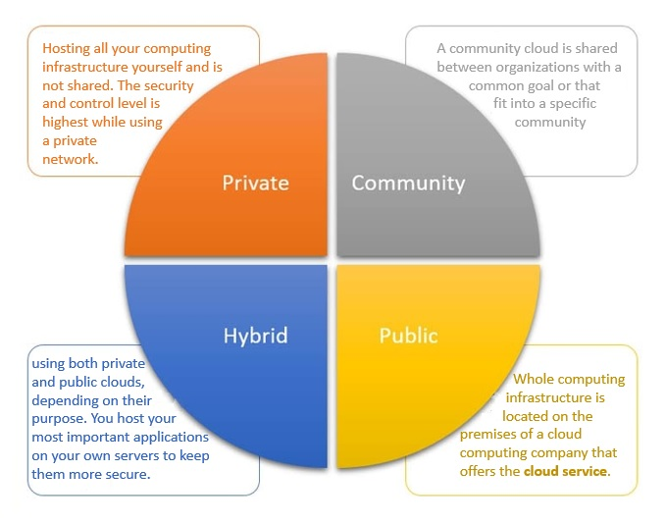

### Three main cloud computing services

**Cloud computing** services fall into 3 categories: infrastructure as a service (IaaS), platform as a service (PaaS), software as a service (SaaS). These are sometimes called the cloud computing stack, because they build on top of one another.

1. **Infrastructure-as-a-service (IaaS)**  
   IaaS is the most basic category of [**cloud computing services**](https://www.esds.co.in/enlight-cloud-hosting) that allows you rent IT infrastructure (servers or VM’s) from a cloud provider on a pay-as-you-go basis.
2. **Platform as a service (PaaS)**

Platform-as-a-service (PaaS) refers to the supply an on-demand environment for developing, testing, delivering and managing software applications. It is designed to quickly create web or mobile apps, without worrying about setting up or managing the underlying infrastructure of servers, storage, network and databases needed for development.

1. **Software as a service (SaaS)**

Software-as-a-service (SaaS) is a method for delivering software applications over the Internet as per the demand and on a subscription basis. SaaS helps host and manage the software application and underlying infrastructure and handle any maintenance (software upgrades and security patching).

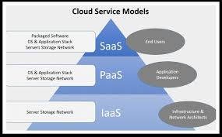

**Uses of cloud computing**

Today a variety of organisations ranging from tiny startups to government agencies are embracing this technology for the following:

* Create new apps and services as well as store, back up and recover data
* Host websites and blogs
* Stream audio and video
* Deliver on demand software services
* Analyze data for patterns
* Make predictions

**Benefits of cloud computing**

There are many benefits to moving your business to the cloud:

* Reduced IT cost
* Scalability
* Business continuity
* Collaboration efficiency
* Flexibility of work practices

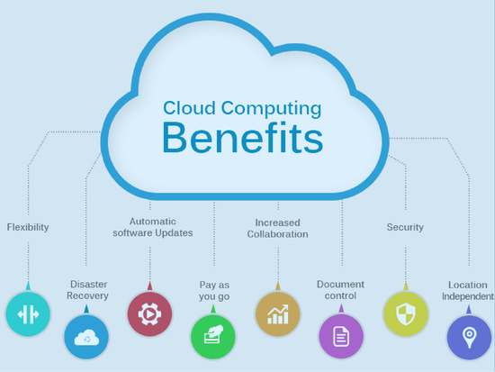

**CLOUD COMPUTING PLATFORMS**

There is a variety of cloud computing platforms offered by cloud services providers.

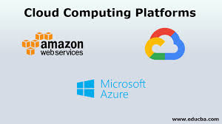

Most used cloud platforms are:

* **AWS( Amazon Web Services)**
* **Microsoft Azure**
* **GCP ( Google Cloud Platform)**

**1. AWS( Amazon web services)**



* Complete set of services that enables you run virtually everything in the cloud.
* No upfront payments.
* Auto scalable.
* Easily migrate existing infrastructure.

Amazon web service is a platform that offers flexible, reliable, scalable, easy-to-use and cost-effective cloud computing solutions.

 The platform is developed with a combination of infrastructure as a service (IaaS), platform as a service (PaaS) and packaged software as a service (SaaS) offerings.

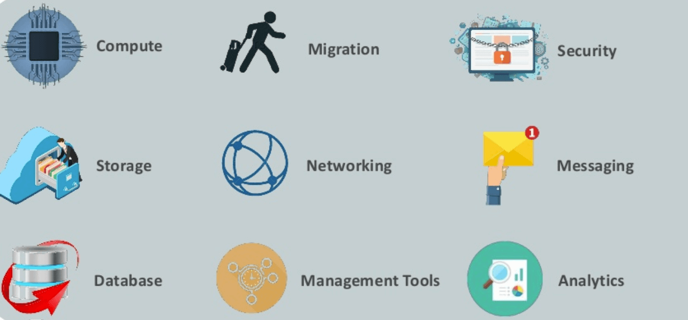

**Amazon computation sevices**

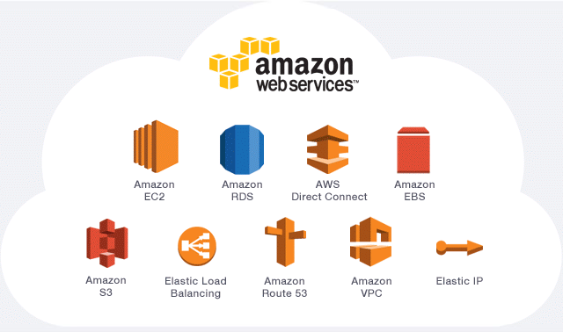

Amazon Elastic Compute Cloud(EC2):

**Amazon EC2** is a web service having a feature of resizable compute in the cloud. It makes the process of web-scale computing easy for developers.

Amazon EC2 allows users to have at their disposal a virtual cluster of computers , available all the time , through the internet . It also provides storage with EC2 instances.

Amazon EC2 provides the following features:

* Virtual computing environments , known as instances.
* Secure login information for your instances using key pairs.
* Persistent storage volumes for data using Amazon EBS volumes.

Amazon simple storage services(S3):



**Amazon Simple Storage Service** is a service offered by [amazon web Services](https://en.wikipedia.org/wiki/Amazon_Web_Services" \o "Amazon Web Services) (AWS) that provides [object storage](https://en.wikipedia.org/wiki/Object_storage) through a [web service](https://en.wikipedia.org/wiki/Web_service) interface.

* S3(simple storage services) – storage service of AWS in which we can store objects like files , folders, images , documents , songs , etc. It cannot be used to install software , games or operating system.
* AWS includes various tools and services designed to help users migrate applications, databases , serves , and data onto its public cloud.
* AWS also provides developer tools , management and monitoring , security and governance , analytics , app development and many more services.

**2. Microsoft azure**

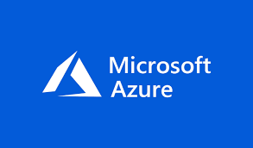

* Microsoft azure is an ever-expanding set of cloud services to help your organization meet business challenges. It’s the freedom to build , manage, and deploy applications on a massive , global network using your favourite tools and frameworks.
* Azure is microsoft’s cloud platform , through which microsoft’s resources use. Microsoft azure provides us with virtual machines , fast processing of data, analytics and monitoring tools and so on to make our work simpler.

* Azure includes virtual machines , virtual machines scales set ,functions for server less computing , cloud computing for building cloud – based apps .
* The azure services platforms is comprised of three cloud centric products: Windows azure , SQL azure and Azure app fabric controller . These are in addition to the application hosting infrastructure facility.

**3. GCP(google cloud platforms)**

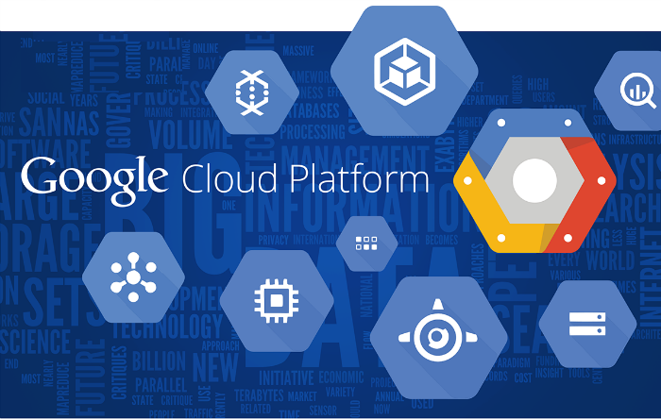

* Google Cloud Platform services can be accessed by software developers, cloud administrators.
* Google Cloud Platform offers services for compute, storage, networking, machine learning and the internet of things , as well as cloud management, security and developer tools.
* The core cloud computing products in Google Cloud Platform include:
* Google compute engine
* Google app engine
* Google cloud storage
* Google container engine

**Which platform is better ?**

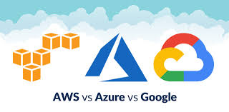  
Compared on the basis of the most common cloud services:

* Availability zone
* Storage Services
* Networking services
* Market share
* Pricing

**Availability zone**

AWS is the oldest hence it has had more time to expand its network. AWS is hosting in multiple locations along with GCP and Azure but there is a difference in the availability zones:

* At present, AWS has 66 availability zones with 12 on the anvil.
* Azure caters to 54 regions worldwide and is available in 140 countries.
* GCP is available in 20 regions around the world with 3 more on their way.

**Storage Services**

* AWS have amazon simple storage services and azure have blob storage and GCP have google cloud storage.
* File storage - AWS is in amazon elastic file system

- Azure in azure file storage

- GCP in avere

**Networking service**

* DNS- Amazon have amazon route S3 and Azure have azure DNS and GCP have google cloud DNS.
* Virtual network- amazon have amazon virtual private cloud(VPC) and azure have virtual networks(VNets) and GCP have virtual private cloud.

**Market shares**

* AWS is leading with around 30% of public cloud share .
* Microsoft azure is on the second place, owning around 16%of the worldwide market share.
* Google, on the third place, owns up to 10% of the market share worldwide.

**Pricing**

* AWS recently started offering pay-per-minute billing .
* Azure already offers pay-per-minute billing.
* Google cloud offers pay-per-second billing models which let users save way more than using AWS or azure.

**CONCLUSION**

* Cloud Computing services has triggered a revolution in the IT industry. It has become a go-to factor for application implementation and hosting for all companies, whether big or small.
* So after discussing different parameters and comparing each cloud platforms then we surely conclude that AWS stand out to be the top cloud platform among the three based on several discussed factor.
* The other two cloud platforms are gaining a good response with growing needs and services of cloud computing.
* **Azure** is a good option for companies that use a lot of Microsoft products and have a need for reliable and effective cloud solutions.
* **AWS** provides the broadest selection of different services and has the biggest reach with its data center all over the world. However, its pricing policies move it towards enterprise-level companies that look for versatile and expansive solutions.